Data Dimension Reduction Techniques

- Motivation

Why is not more data always better? In theory it is better. To quote a quote from the Weka book:

“What’s the difference between theory and practice?” “There is no difference, in theory. But in practice there is.”

The goals of data dimensionality reduction include improving machine learning algorithm performance and reducing machine learning run time. Redundant and irrelevant attributes can confuse some learning algorithms. Learning algorithms can take longer the more attributes there are. Sometimes there are so many attributes that the learning process becomes impractical.

For divide and conquer approaches to machine learning irrelevant attributes start to look like good choices after enough divisions of the data set occur. For example, decision tree models aim to divide the data set by choosing attributes that differentiate them. When a decision tree get deep, leaf nodes having many ancestors, it is possible that an irrelevant attribute might by chance be a “good” choice for the next node. It may by chance separate the remaining training data instances well. When a new instance comes in the model at this point in the tree has little guarantee of describing it.

The data set we are studying is for pancreatic cancer patients. The main goals are to improve accuracy of predicting life span and quality of life for these patients. Pancreatic cancer occurs infrequently, there are not many data instances in our data set. There are many attributes though. We hope to leverage data dimensionality reduction techniques to improve prediction accuracy of the models built by machine learning algorithms.

- Introduction

The basic approach to dimensionality reduction is selection, evaluating, and stopping. From the space of all possible features a subset of those features is selected. The subset of features is then evaluated. There are criteria for stopping the search, hopefully after a good subset of features is selected.

Two main approaches are filter and wrapper. These two methods differ only in how the evaluation step is performed. The wrapper method uses the target machine learning algorithm to produce a model using the subset of features. It then uses the performance of that model to determine if the subset of features is good. The filter method evaluates the subset independent of the target machine learning algorithm.

An example of a simple filter could use a decision tree. Choosing the top most nodes of the decision tree represent the attributes the decision tree algorithm picked as the best to predict classification. While using just this subset of attributes to build another tree would result in a very similar model, using them in another machine learning algorithm can yield better results. This is also an example of using an embedded attribution selection of a machine learning algorithm as a filter.

3.0 Feature Selection and Extraction

Feature selection and feature extraction treat the original attribute set differently for the purpose of dimensionality reduction. Feature selection involves simply selecting a subset of the existing attributes of a data set. Feature extraction creates a new set of attributes from the original. The new set of attributes may use all the original attributes but not necessarily.

3.1 Feature Selection

Examples of feature selection include Decision Trees, Support Vector Machines (SVM), ReliefF, and Correlation Based Feature Selection (CFS).

ReliefF weights attributes by selecting the k nearest and k furthest neighbors (distance based on the attribute being weighted) and adjusting the weight based on the class of these neighbors. The highest weighted attributes are selected.

3.1.1 Correlation Based Feature Selection (CFS)

CFS aims to select a subset of attributes that are individually correlated well with the target class attribute but have little correlation between themselves.

Symmetric uncertainty:

U(A,B) = ( 2 H(A) + H(B) - H(A,B) ) / ( H(A) + H (B) )

Where:

H = entropy function, probability associated with each attribute value
H(A,B) = joint entropy of A and B, probability of all combinations of values of A and B

to define a Correlation Metric:

∑ U(A_{j},C) / ∑ ∑ U(A_{i},A_{j})
j i j

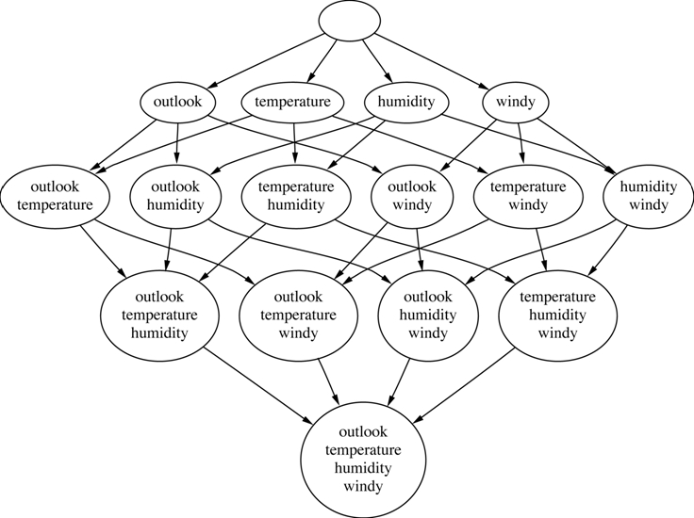

Any search method over the attribute subset space can be used with the correlation metric. A top down method would start with the empty set and add attributes to the set as the search continues. A bottom up method would start with the complete set of attributes and remove them as the search continues.

3.2 Feature Extraction

Examples of feature extraction include Principal Component Analysis (PCA), Factor Analysis, and Local Linear Embedding.

Factor Analysis aims to express original attributes as a small number of hidden or latent attributes. A latent attribute summarizes a group of attributes correlated to each but not the other attributes in the set.

Local Linear Embedding aims to analyze overlapping local neighborhoods. Each data point is weighted based on nearest neighbors. Using weights, each data point are mapped to a lower dimensional point.

3.2.1 Principal Component Analysis (PCA)

PCA is an orthogonal linear transformation of the original data set. Given the shown set of three-dimensional data points notice they are mostly distributed on a two dimensional surface. PCA will try to find a two-dimensional parameterization of the data set.
PC 1

First PCA finds a three-dimensional vector in the directions of maximum variance. PC1 shown is a linear combination of the 3 original coordinates. The vector accounts for the most variance in the data set, but not necessarily all. It will take a maximum of three vectors.
PC 1
PC 2

The second vector corresponding to the second largest amount of variance is orthogonal to the first.

PC 1
PC 2
PC 3

The third vector accounts for the smallest amount of variance. It is by discarding, or not using this vector to project the original data set points into the new coordinate system, that data dimensionality reduction is achieved.
PC 1
PC 2
PC 3
PC 1
PC 2

If the data set can be expressed well by two dimensions by PCA, the first two vectors describe the plane upon which the majority of the points lie.

If the third vector is kept it is possible to translate points between the two coordinate systems, the original defined by the original attributes and the PCA found one.

PCA is also used for information retrieval (Latent Semantic Indexing).

